

**EAL Highland**

**Reproduced with thanks to Milton Keynes Council**

**Assessment of Newly Arrived Pupils**

**Learning**

**English as an Additional Language**

**P4-7**

**Contents**

**Introduction**

Context

Overview of the Assessment Process

**Recording Sheets**

Observations recording sheet

Initial Assessment Recording Sheet

**Assessment**

Assessment of listening and understanding

Assessment of speaking skills

Assessment of reading skills

Assessment of writing skills

Assessment of mathematical language and calculation skills.

**Setting Targets**

EAL Profile of Competence

**Overview of the Assessment process**

**Assessment of listening and understanding skills**

**Instructions**

1. Give the student simple instructions using the school environment and objects/ pictures e.g.

* Close the door please
* Come and sit next to me
* Draw your house/ family
* Show me the dog in the picture

1. Use familiar objects to give two consecutive instructions e.g.

* Put the pencil on the book
* Put the ball on the chair
* Open the book at page 10

**Identifying a picture from a description**

1. Use **listening sheet 1** to assess the student’s ability to understand a simple description. Read out the following descriptions and ask the learner to identify the picture on ***Listening Sheet 1.***

* *He has black hair. He is wearing a green T-shirt and blue shorts.*
* *She has long blonde hair. She is wearing a blue skirt and a green T-shirt. She is reading a book.*
* *He has grey hair and has a beard. He is wearing grey dungarees and has a big brown hat.*
* *She has brown hair. She is wearing an orange dress. She is eating.*
* *He has short blonde curly hair. He is wearing blue trousers and an orange shirt. He is walking his dog.*
* *She has blonde hair. She is wearing a pink dress and red and white shoes. She is running.*





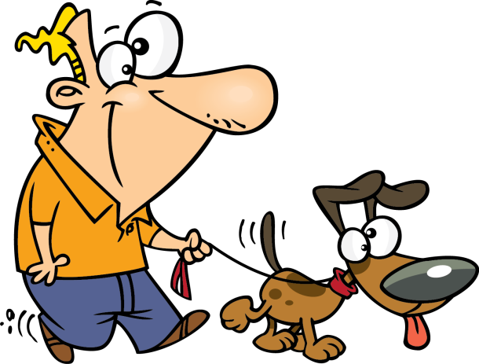





**Assessment of Speaking Skills**

**Silent Period**

1. **Personal Information (speaking sheets 1-2, atlas)**

* Ask the student simple questions using the visuals e.g.

Where are you from?

Where do you live now?

What was your house like in ______?

What is your house like in Scotland/ name of the town?

Do you have any brothers or sisters?

Do you have any pets?

How old are you?

**Note:** *You can help the student’s understanding by modelling the language first using the visuals as support e.g. I have 2 brothers, do you have any brothers or sisters? (pointing to the pictures as you speak)*

1. **Colours – use coloured pencils**
2. **Naming vocabulary (Speaking sheets 3/5)**
3. **Speaking in sentences – present tense/ past tense**

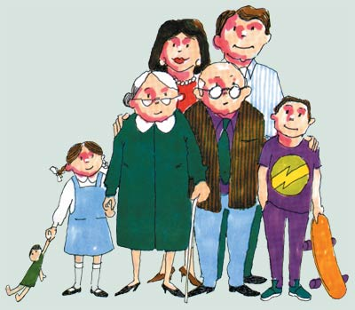

**Family**

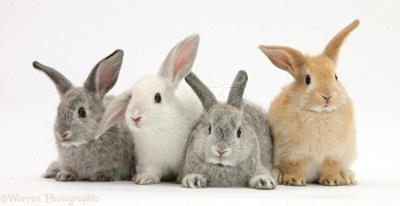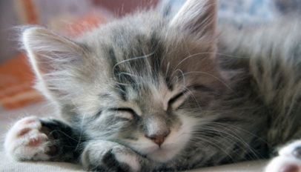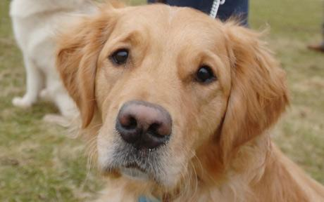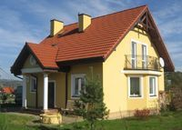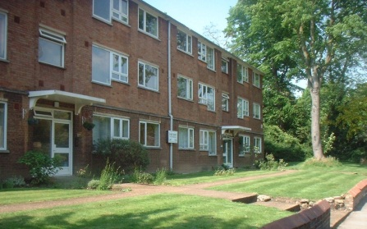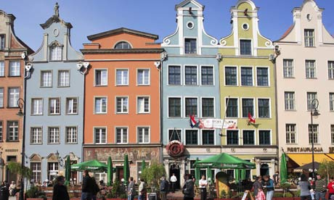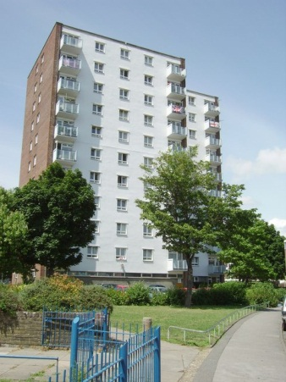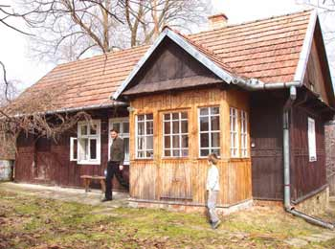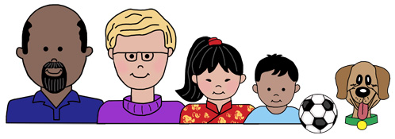

**Houses**

**Pets**

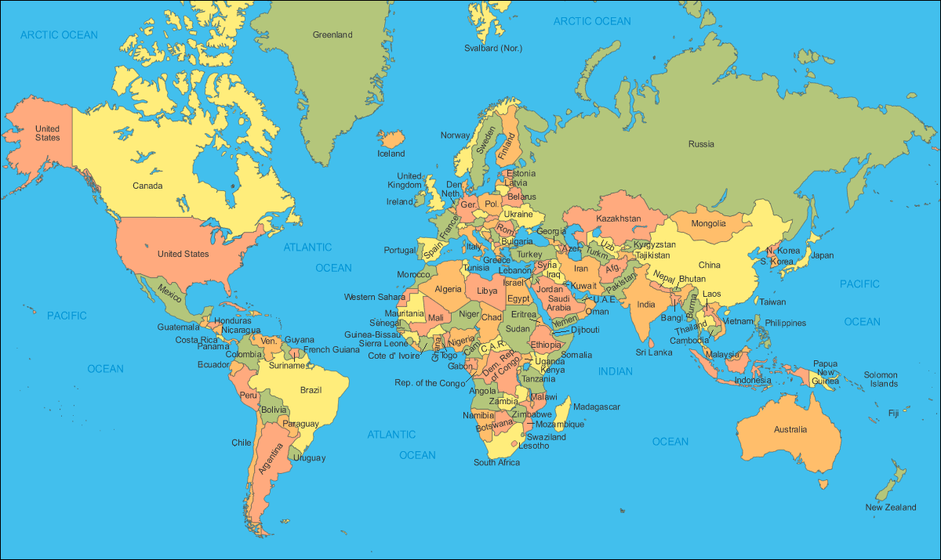

**School items:**

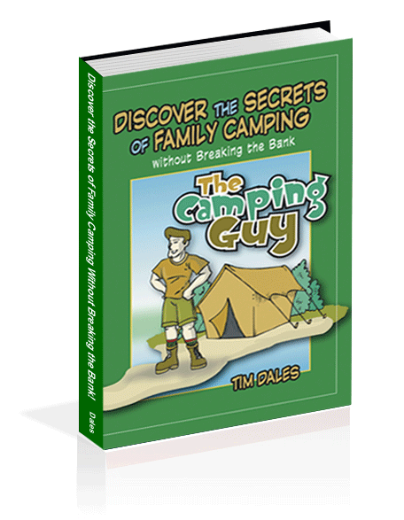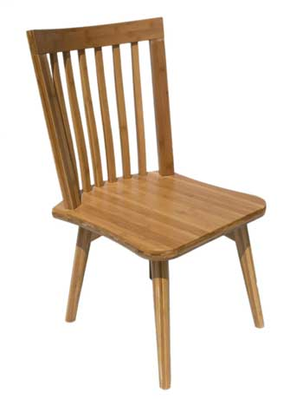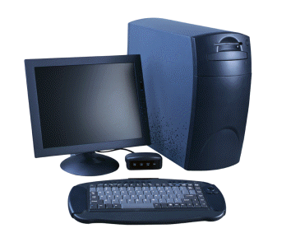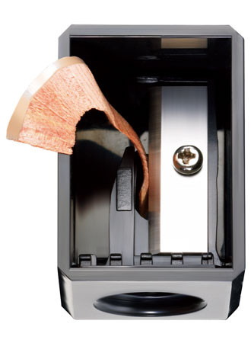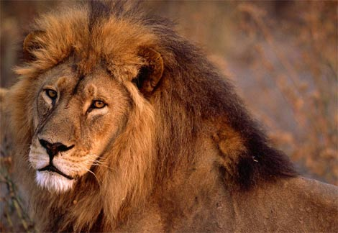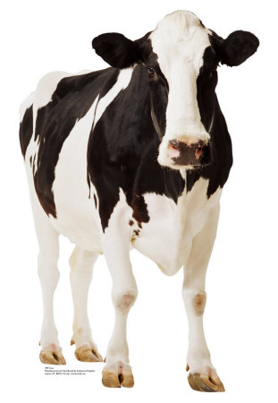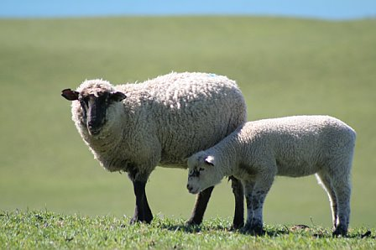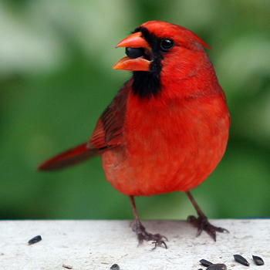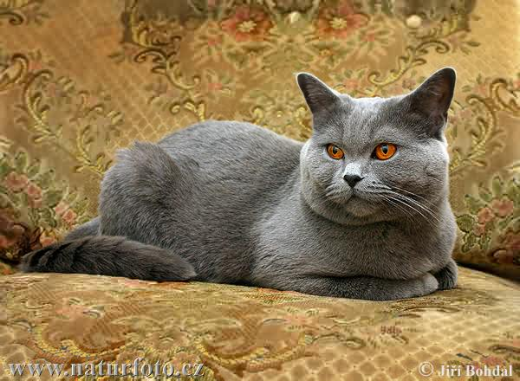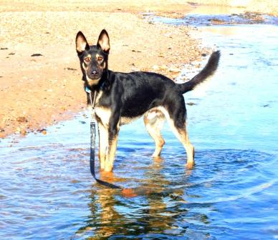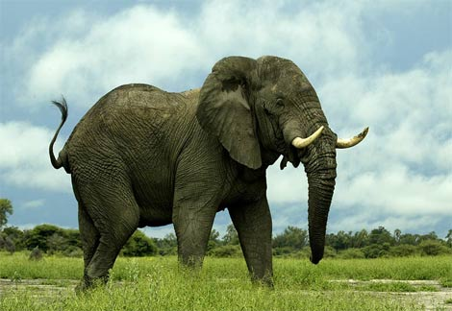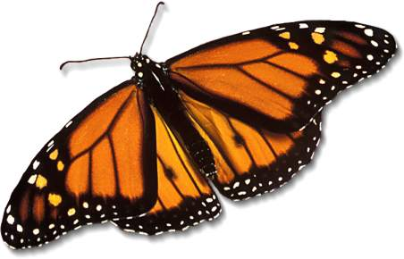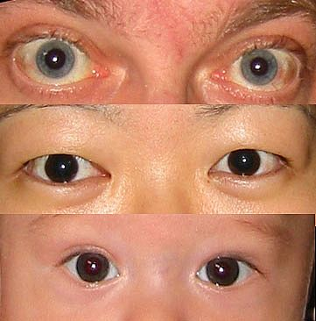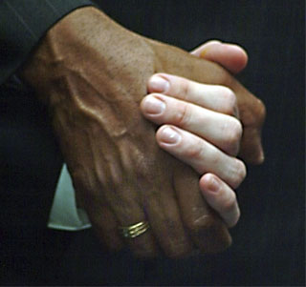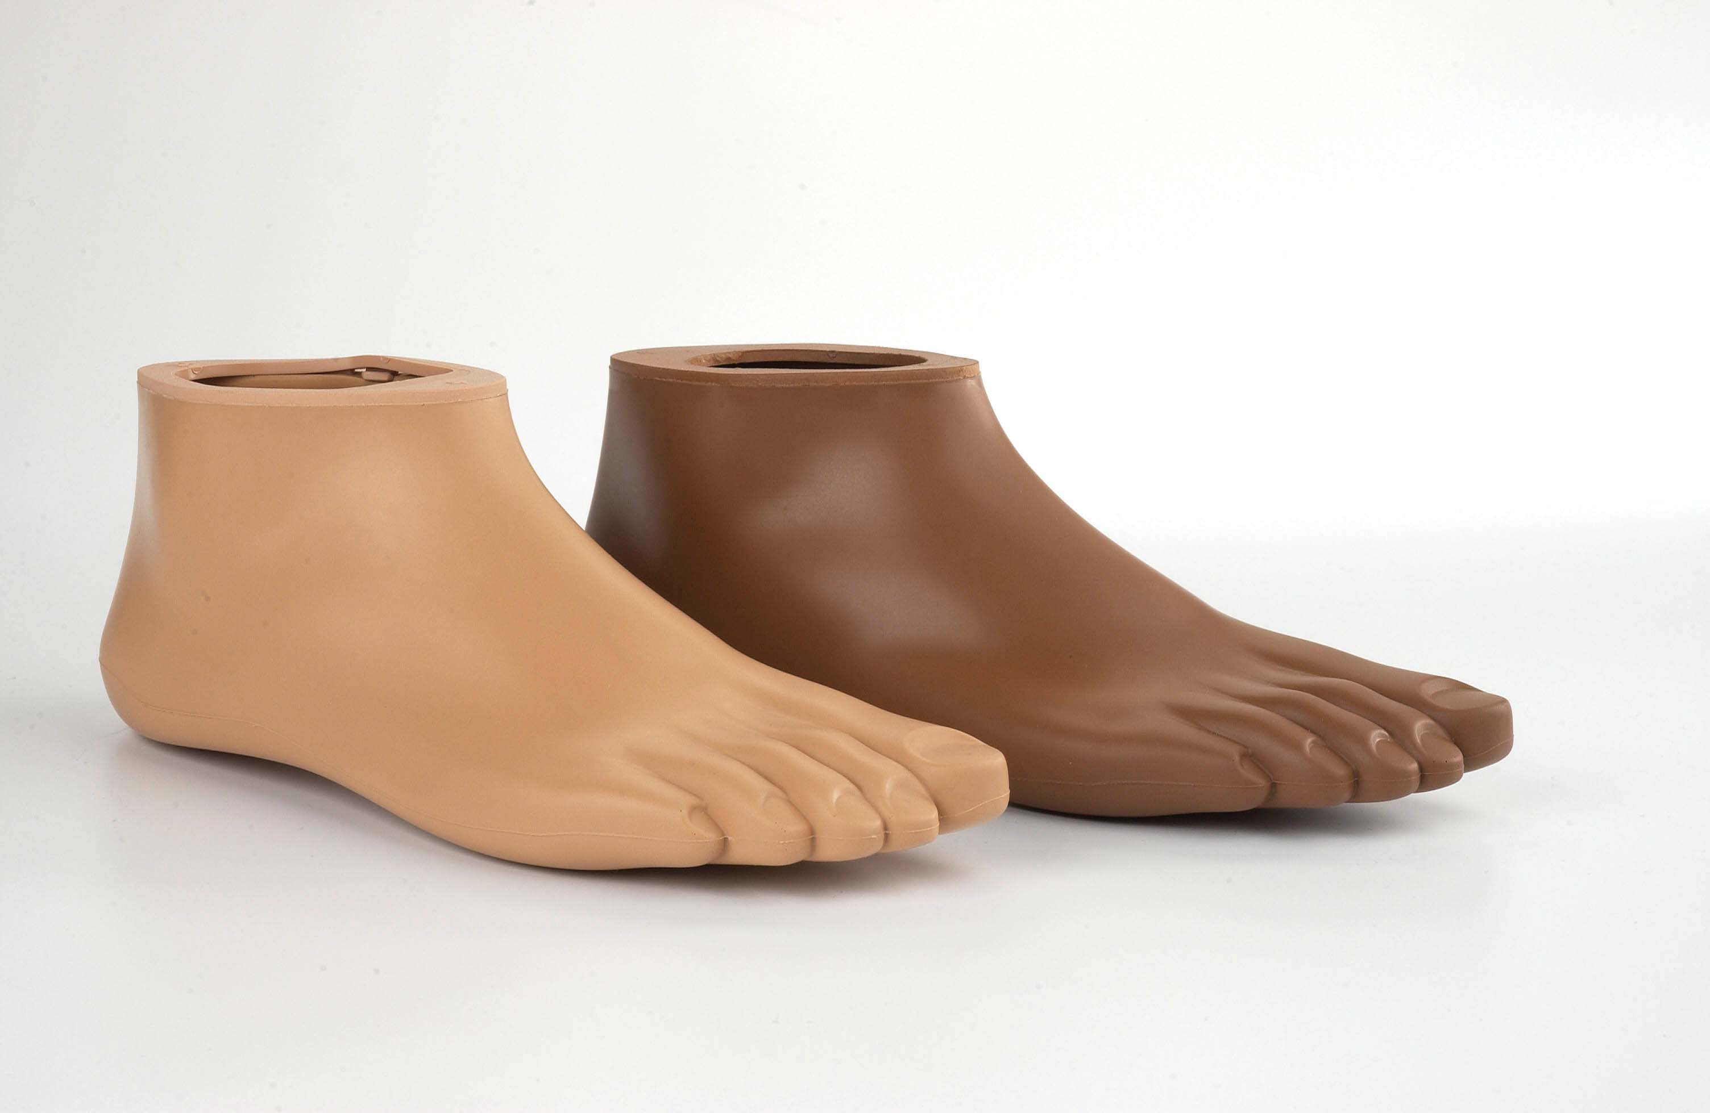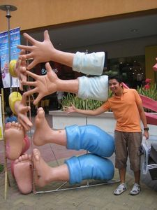

**Body parts:**

**Animals:**

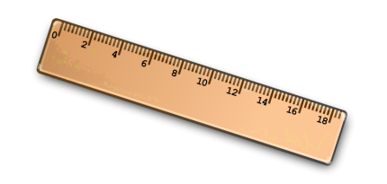

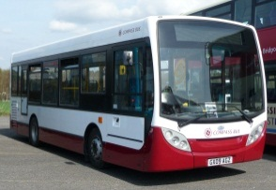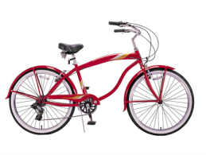

**Transport**



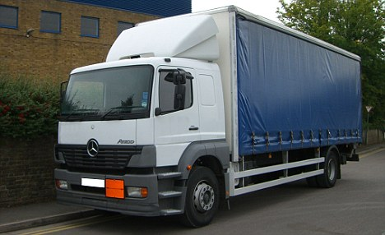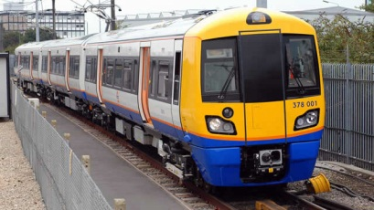

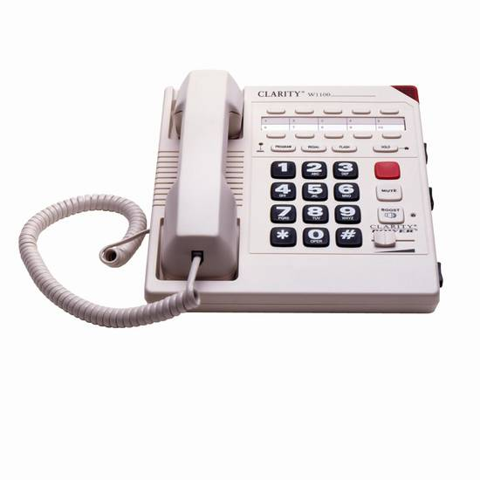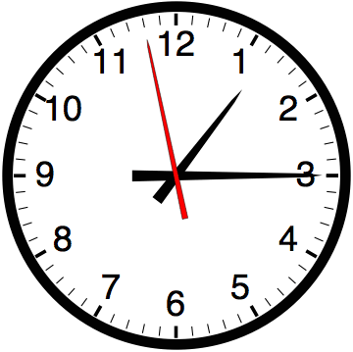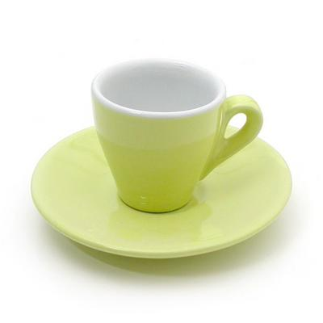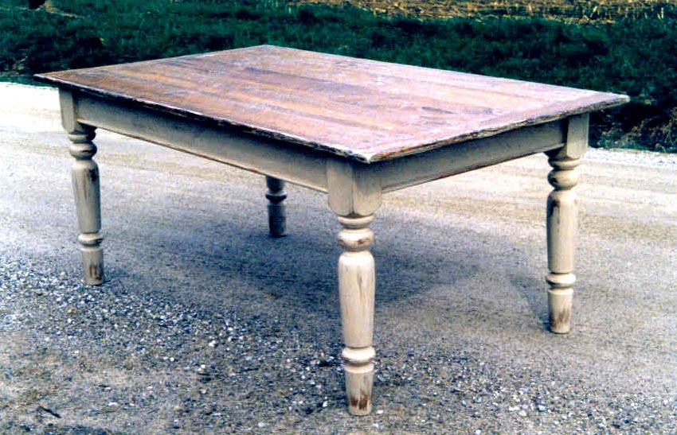

**Household items:**

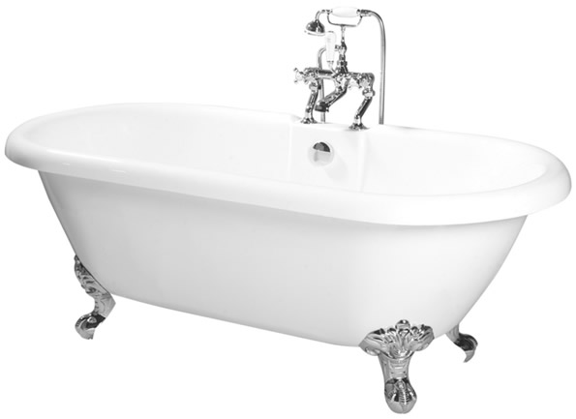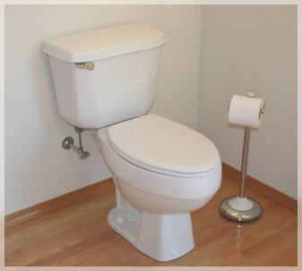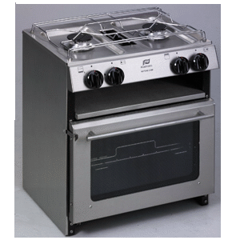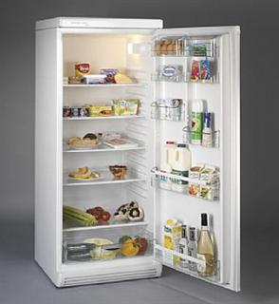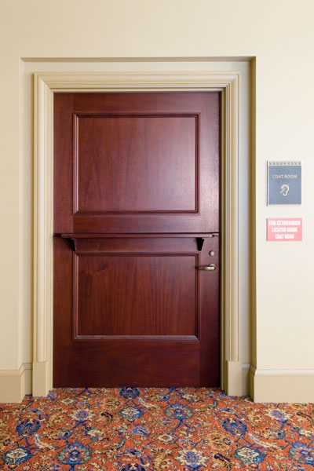

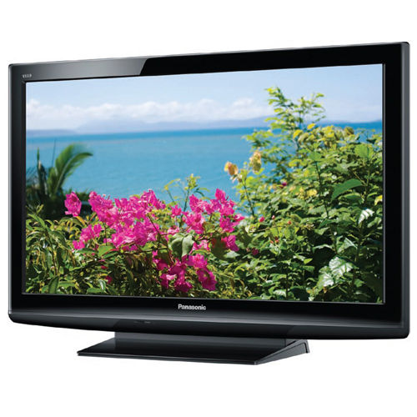

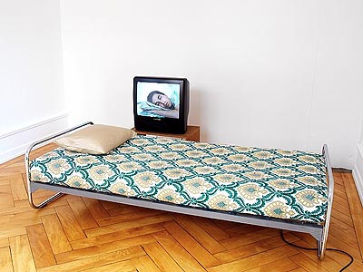

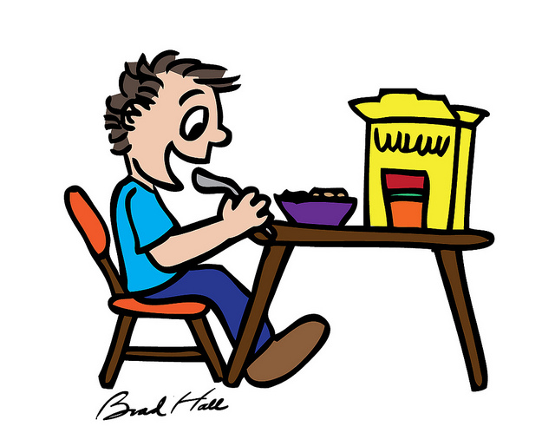[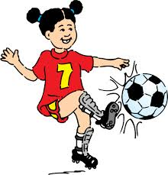](http://www.google.co.uk/url?sa=i&source=images&cd=&cad=rja&uact=8&docid=fp_zi7L0fgVA5M&tbnid=Ty-nPJ4ATa46vM&ved=0CAgQjRw&url=http://www.clker.com/clipart-football-girl.html&ei=hI70U4XAAYnC7AaazoAg&psig=AFQjCNHrh37YbqaEPsCNBkQiuvlN3hipvg&ust=1408622596107725)

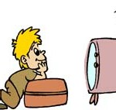[](http://www.google.co.uk/url?sa=i&rct=j&q=&esrc=s&frm=1&source=images&cd=&cad=rja&uact=8&docid=c24jFO1wwkR-TM&tbnid=wKUQv7lBFRB9SM:&ved=0CAUQjRw&url=http://planetsehat.com/tips-diet/7-alasan-utama-anda-tidak-bisa-menurunkan-berat-badan/&ei=l5D0U4aOO8mf7Aau5YHwDw&psig=AFQjCNHg_4FvdYozcd2ke9q2gJ2NH0NvbA&ust=1408623063709586)

***Match the word with the picture***

**Reading Sheet 1**

|  |  |  |  |  |
| --- | --- | --- | --- | --- |
| [https://encrypted-tbn1.gstatic.com/images?q=tbn:ANd9GcSkbMmiCF0q90wgPddOK7ItlpMA2lycOt26WR5M2eT-6v98ay1s](http://www.google.co.uk/url?sa=i&rct=j&q=&esrc=s&frm=1&source=images&cd=&cad=rja&uact=8&docid=W7jbJRKcvtYt1M&tbnid=97s9NJDmf0skIM:&ved=0CAUQjRw&url=http://freefunnydogpictures.com/cartoon-dog-free-wallpapers-2014/&ei=dLb0U_CSFeel0QWAlICICg&psig=AFQjCNGL8hjzUdx57bZpX_YxV1RHH4Pa4w&ust=1408632786593078) | http://4.bp.blogspot.com/-5N9aoYoe0ko/UXffwll0u3I/AAAAAAAAFkk/NHpq6si6EIo/s640/red+cartoon+car.gif | http://www.lessentiers.net/images/horloge.png | http://static8.depositphotos.com/1168906/900/v/450/depositphotos_9008264-Cartoon-sneakers-shoe.jpg | http://cdn.vectorstock.com/i/composite/69,98/banana-fruit-cartoon-vector-1346998.jpg |
| **car** | **shoe** | **banana** | **dog** | **clock** |

**Read the words**

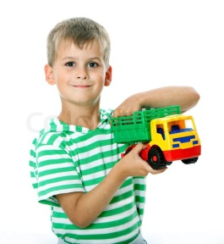

**1.The boy had a car.**

**2.The girl and her mum went to the shops.**

**3.Dogs like bones.**

***Read the sentences***

.

**Reading Sheet 2**

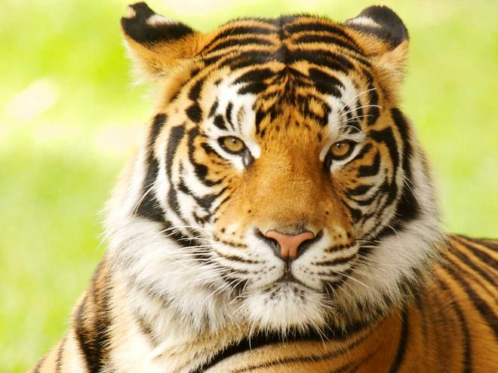

**Reading Sheet 2**

Tigers

Tigers are big cats which live in Asia. They are orange with black and white stripes. Tigers are carnivores. They eat lots of different kinds of animals like frogs, birds, pigs and deer. Tigers live in forests and like to live near water.

1. What colour are tigers?
2. What do they eat?
3. Do tigers like to live near water.



**Reading Sheet 3**

**Tigers**

|  |
| --- |
| The tiger is the biggest of all cats and lives in Eastern Asia. They have a thick furry coat which is orange with black and white stripes. A tiger can live for more than 20 years and they usually like to live on their own. Tigers can live in grasslands, forests, rocky areas and savannahs. They are strong swimmers and like to live near water.  Tigers are night hunters and eat deer, wild pigs and other mammals where they live. People also hunt tigers for their fur and there are only 3 500 left in the world.   1. How long do tigers live for? 2. What do tigers eat? 3. Why do people hunt tigers? |

|  |
| --- |
|  |

|  |  |  |
| --- | --- | --- |
|  |  |  |

|  |
| --- |
|  |

|  |  |  |
| --- | --- | --- |
|  |  |  |

|  |
| --- |
|  |

|  |
| --- |
|  |

|  |  |  |
| --- | --- | --- |
|  |  |  |

**Reading Sheet 4**

**Phonic assessment**

Tigers

Recognizing a tiger at the zoo is easy. But in their natural habitat, tigers are really hard to find. That’s because their unique orange, black and white striped pattern helps them blend into the forests and grassy areas where they live and hunt.

Tigers are carnivores. They are quiet, patient hunters with large powerful paws and teeth to help them catch and eat their prey. Some of their favourite meals include pigs, deer, rhinoceroses, and even small elephants.

Tigers hunt for their food but they are also hunted by humans for their valuable fur and body parts. Because of this, tiger researchers think there may only be 3,500 tigers left in the world. This makes them an endangered species.

1. Why are tigers difficult to see in their natural habitat?
2. Why are tigers good hunters?
3. Why are there only 3 500 tigers left in the world?

**Lower case letters:**

|  |  |  |  |  |  |  |  |  |  |  |  |  |  |  |  |  |  |  |  |  |  |  |  |  |  |  |
| --- | --- | --- | --- | --- | --- | --- | --- | --- | --- | --- | --- | --- | --- | --- | --- | --- | --- | --- | --- | --- | --- | --- | --- | --- | --- | --- |
|  | **c** | **j** | **m** | **p** | **t** | **u** | **a** | **e** | **s** | **x** | **f** | **b** | **q** | **z** | **d** | **i** | **v** | **g** | **l** | **n** | **r** | **k** | **y** | **h** | **o** | **w** |
| **name** |  |  |  |  |  |  |  |  |  |  |  |  |  |  |  |  |  |  |  |  |  |  |  |  |  |  |
| **sound** |  |  |  |  |  |  |  |  |  |  |  |  |  |  |  |  |  |  |  |  |  |  |  |  |  |  |

**Capital letters:**

|  |  |  |  |  |  |  |  |  |  |  |  |  |  |  |  |  |  |  |  |  |  |  |  |  |  |  |
| --- | --- | --- | --- | --- | --- | --- | --- | --- | --- | --- | --- | --- | --- | --- | --- | --- | --- | --- | --- | --- | --- | --- | --- | --- | --- | --- |
|  | **W** | **O** | **H** | **Y** | **K** | **R** | **N** | **L** | **G** | **V** | **I** | **D** | **Z** | **Q** | **B** | **F** | **X** | **S** | **E** | **A** | **U** | **T** | **P** | **M** | **J** | **C** |
| **name** |  |  |  |  |  |  |  |  |  |  |  |  |  |  |  |  |  |  |  |  |  |  |  |  |  |  |
| **sound** |  |  |  |  |  |  |  |  |  |  |  |  |  |  |  |  |  |  |  |  |  |  |  |  |  |  |

**CVC:**

|  |  |  |  |  |  |  |  |  |  |
| --- | --- | --- | --- | --- | --- | --- | --- | --- | --- |
| cat | bag | net | leg | pin | kit | pot | box | mug | sun |
|  |  |  |  |  |  |  |  |  |  |

**words with adjacent consonants:**

|  |  |  |  |  |  |  |  |  |  |  |  |
| --- | --- | --- | --- | --- | --- | --- | --- | --- | --- | --- | --- |
| plum | crab | twin | step | skip | smell | sniff | cross | chin | shop | thin | think |
|  |  |  |  |  |  |  |  |  |  |  |  |

**words with long vowel phonemes:**

|  |  |  |  |  |  |  |  |  |  |
| --- | --- | --- | --- | --- | --- | --- | --- | --- | --- |
| train | tray | seen | leap | hide | night | boat | hole | moon | tune |
|  |  |  |  |  |  |  |  |  |  |

**Assessment of writing skills**

**Introduction**

The person assessing the student will need to look at examples of writing completed in class and observe the student in English lessons, before administering a more formal writing assessment. If enough information has been obtained in class, it may not be necessary to withdraw the student to assess his/her writing in a one-to-one situation. However, staff may find it useful to ascertain the student’s level of English when writing unaided and to make a formative assessment from this work.

If the student does not appear to have any knowledge of writing, a copying exercise has been included on the following guidance sheet, to help assess those students at step 1.

Assessors could select from Writing Sheets 1 – 4, which may be useful starting points for a one-to-one assessment in writing.

Guidance and activities

To build up a profile of the student’s English writing skills, the following stages can be followed:

Provide lined paper and ask the pupil to write his/her name. Then, ask/indicate that you want him/her to copy the three items below. (Adapt these according to previous education.)

1. **b R o p s t z L M a f g p k**
2. **cat dog baby apple**
3. **I am at school in Scotland**

If the student is able to write in English, you could ask him/her to write about a picture, or write the story that he/she narrated earlier in the speaking activity. Some students may be able to write about their experience of arriving in the UK.

Writing Sheets 1 – 3 have been included to give students the opportunity to write about something they are familiar with. Staff can select their own picture that they feel is most appropriate for the individual being assessed.

If the student is able to write in English, but needs help with sentences, staff could adapt the sentence completion Writing Sheet 4, or use it in its entirety for more advanced learners of English.

The student’s responses can be recorded on the Initial Assessment Profile sheet.

For students who can write in their first language, the one-to-one assessment session can provide an opportunity to find out about their first language literacy skills too.

Writing Sheet 1

_ b_d e _ _h _ j k l m _ o _ q r s _ _ v _ x y z

A _ C D _ _ _ H I _ _ L M _ O _ Q _ _ T U _ W X _ _

|  |  |  |
| --- | --- | --- |
| http://images.clipartpanda.com/smiling-sun-clipart-black-and-white-16776-sun-outline-clip-art.png |  | http://home-design-information.com/wp-content/themes/picpro/thumb.php?w=175&h=140&zc=2&src=http://home-design-information.com/wp-content/uploads/2013/12/bed-clipart---jobspapa-8iegnzit.jpg |
| **_ _ _** | **_ _ _** | **_ _ _** |
| http://www.qacps.k12.md.us/ces/clipart/Carson%20Dellosa%20Clipart/Carson%20Dellosa%20Learning%20Themes/Images/Black%20and%20White%20Images/Ocean/FISH7_BW.bmp | http://images.clipartpanda.com/spoon-clip-art-spoon-clip-art-9.gif | http://images.clipartpanda.com/teeth-clip-art-nicubunu_Mouth_with_teeth_Clipart_Free.png |
| **_ _ _ _** | **_ _ _ _ _** | **_ _ _ _ _** |
| http://pad1.whstatic.com/images/thumb/6/66/Cha5.jpg/460px-Cha5.jpg | http://www.clipartbest.com/cliparts/MTL/zXp/MTLzXpGTa.png | http://www.how-to-draw-funny-cartoons.com/image-files/cartoon-table-4.gif |
| **_ _ _ _ _** | **_ _ _ _ _ _** | **_ _ _ _ _** |

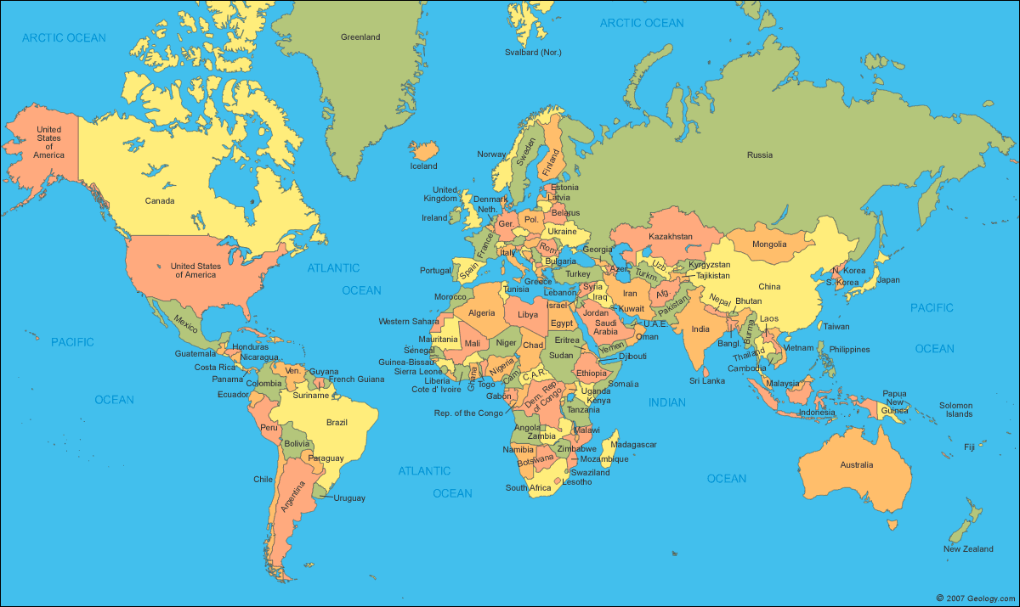

Writing Sheet 2

________________________________________________________________________________________________________________________________________________________________________________________________________________________________________________________________________________________________________________________________________________________________________________________________________________________________________________________________________

Write about yourself in ________________

Writing Sheet 3

Finish the sentences:

1. I like ……………………………………………………………………………………………

2. I don’t like …………………………………………………………………………………

3. I can ……………………………………………………………………………………………

4. I can’t …………………………………………………………………………………………

5. Yesterday I ………………………………………………………………………………

6. Tomorrow ………………………………………………………………………………

7. Next weekend ………………………………………………………………………….

9. When I leave school I would like to ………………………………………

10. In my opinion television ……………………………………………………………