Updating SEEMiS for EAL pupils - Guidance
E A L H i g h l a n d
Why?
Information about EAL pupils needs to be inputted onto SEEMiS accurately so that:-
- Teachers can have access to up to date information about pupils
- SCOTXED returns are accurate (links with funding to schools)
- ASN returns are accurate (links to staff provision and support to pupils)

Where the information comes from?
General information about the pupil (name, languages spoken at home, previous schooling, date started Scottish education, etc) comes from enrolment forms filled in by parents and staff at enrolment interview stage (further support on Enrolment for EAL pupils available from EAL team). Other information such as level of English comes from EAL Profiles which are updated biannually (Primary schools) or annually (High schools) – guidance in updating EAL Profiles available from EAL Team.

Completing SEEMiS:
You will need to have editing rights to be able to carry out these tasks. If you do not have the correct access please request the Head Teacher to authorise access through your school office or the MIS Manager for your school.

APPLICATION>>RECORDS>>EDIT
Basic screen
Important information includes
- First Name, Surname and Known As – check it is accurately spelt and ask the pupil how it is pronounced

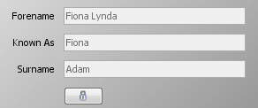

Language Screen

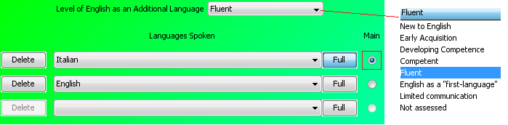

- Languages spoken shows the different languages spoken in the home. When more than one language is spoken at home, enter languages of both parents/carers.
- Level of English shows the level that the pupil is working at as detailed on the EAL Profile.
- If there are different levels for Listening & Talking, Reading or Writing record the lowest level.
- The default entry is ‘English as a First Language’. If there is another language spoken at home (see above field) this field should be changed to ‘Not Assessed’ until a time when an EAL profile is set up and a level of language can be recorded. If this is left as the default entry then the pupil will not be included as EAL.
(IMPORTANT NOTE: Parents can sometimes put ‘English as a First Language’ on the enrolment form but if another language appears in the Languages Spoken field, this should be changed. Instead put ‘English’ as one of the languages spoken at home and click ‘Main’ to show that parents feel that English is the Main language of the child. This will then still flag up the pupil as EAL as there may still be language or cultural literacy issues. If the child is assessed as completely Fluent and has no differentiation in class then their level of English will be recorded as Fluent).

Personal Page>>ASN

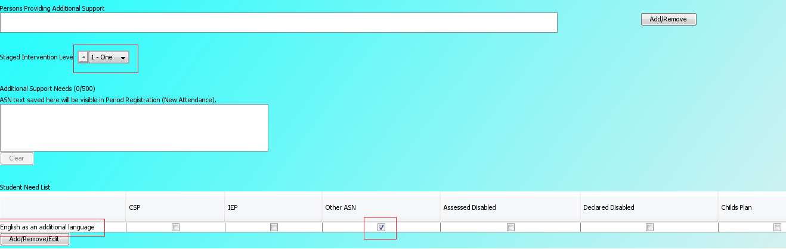
- Level of Need – all EAL pupils with a Level of English that is not Fluent should be entered as Level 1. This is because they will need some differentiation within the classroom setting. If an EAL pupil requires additional support from PSA’s or other teachers then their level will be raised to Level 2 for the period during which they are receiving this support. An example of this would be when a New to English pupil is receiving additional support through Big Bear Banter, Induction programme etc. If EAL pupils have additional needs above and beyond EAL then the level will reflect the level of need appropriately.
- Reason – should reflect English as an Additional Language and click Other ASN to show that there is an EAL profile to support the information that is on SEEMiS which has targets, is supported by the EAL Strategies and is reviewed regularly.

APPLICATION>>RECORDS>>PUPIL PROFILE
Admissions

- Date started U.K. education informs expected progress (it takes around 7 years to become fluent). The Admission Status button can identify the last Scottish School that the pupil was enrolled in.

For more information about pupils with EAL
please contact the EAL Team by emailing peter.fenton@highland.gov.uk

