8. Action Tree

When planning a piece of work about a subject it is helpful to look at the bigger picture. Creating an Action Tree can help you to do this.
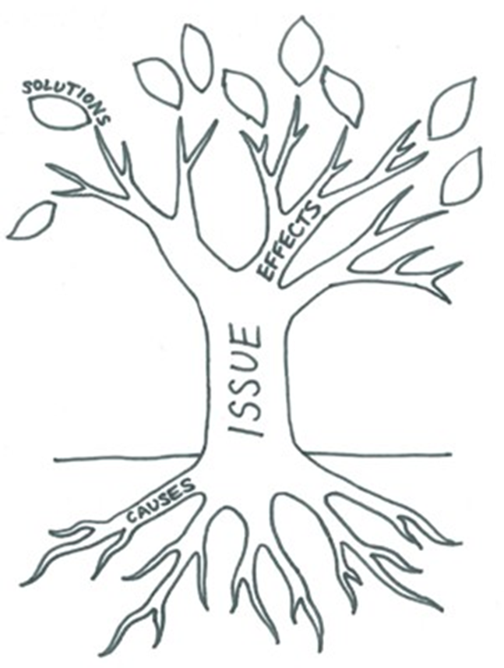
Step 1: Draw a tree with a trunk, roots, branches and leaves.

Step 2: Put the subject or issue in the trunk of your tree.

Step 3: In the roots put the causes of the subject or the issue. What things
have created it, why it haoppens.

Step 4: In the branches put the effects that the subject or issue has had,
the consequences.

Step 5: In the leaves you can put the solutions or next steps.

Then you can see at a glance the causes, effects and solutions of any given issue or subject.

Another way of looking at issues is the Development Compass Rose

Put the issue on the middle and then look at the different causes and effects it has on the world, money and cost, the people and who makes the decisions about it.

These things can help you plan an essay or help with revising about an issue and give you a clear picture of different things you need to include when talking or writing about a subject or an issue.

Try it out with one of the following issues/ subjects:-

- World War 2
- Using plastic
- Gaming addiction
- Emigration
- Eating a healthy diet (or Vegan diet)
- Lady Macbeth’s actions

