5. Graphic Organisers
Graphic organisers help you organise your thoughts before speaking or writing, or they can help you to understand what information is contained in a text after reading it. This makes your learning easier and is great for revision too.
There are different types of graphic organisers and they can be used for different purposes.
It is important to think about the language function you would like to practise and then decide which kind of graphic organiser is the most appropriate:
- Explaining cause and effect: to help learners explain and answer ‘Why?’ questions useful graphic organisers include Ishikawa diagrams and tables
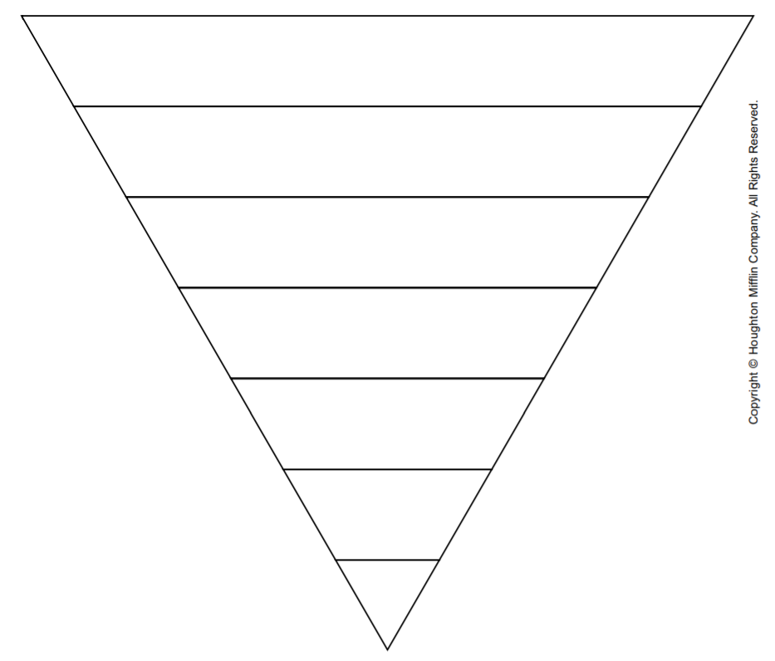

- Prioritising: to provide scaffolding for a discussion activity where learners are asked to rank different ideas in priority order useful graphic organisers would be pyramids, ladders or diamond shapes
- Sequencing: to provide scaffolding for learners to retell stories, recount events or describe processes, flow charts, timelines, cycles and action strips are useful
- Classifying: to enable learners to discuss the characteristics or properties of objects / substances / animals etc., useful graphic organisers include tables and matrices
- Comparing and contrasting: useful graphic organisers include Venn diagrams, fact files and grids

There are lots of graphic organisers that you can use on https://www.eduplace.com/graphicorganizer/

