- VOCAB CARDS / QUIZLET

When you come across new words or concepts you can make cards to help you remember or revise them. Make a set of small cards about the size of a phone, write the word on one side and then the meaning/ translation on the other. Or if that is too simple put a concept on one side and the definition on the other. Then put your cards in an envelope and stick on your bedroom door and every time you go in or out grab a handful of cards and test yourself by reading one side of the card and then saying what is on the other side – without looking ! When you think you have remembered it really well you can get rid of the card.

For example:
Colours (English / Bengali)
One side | Other side
Red | Laal
Blue | Nil
Green | Shobuj
Yellow | Holud

Biology terms
One side | Other side
Vertebrate | With a back bone
Invertebrate | Without a backbone
Mammal | Animal that gives birth to live young
Amphibian | Animal at home in water and on land

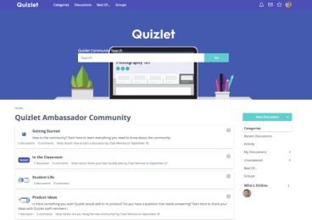
You can make cards up on Quizlet on your phone or chromebook and play on line. You can even share these with friends just sign up for free.
https://quizlet.com/latest

Hexagons

Another great idea is to create hexagons. Put words from a topic onto the hexagons, mix them up and then put them together making sure that you can explain the connection between each touching hexagon. The more you have the more difficult it becomes!
Explain the connection
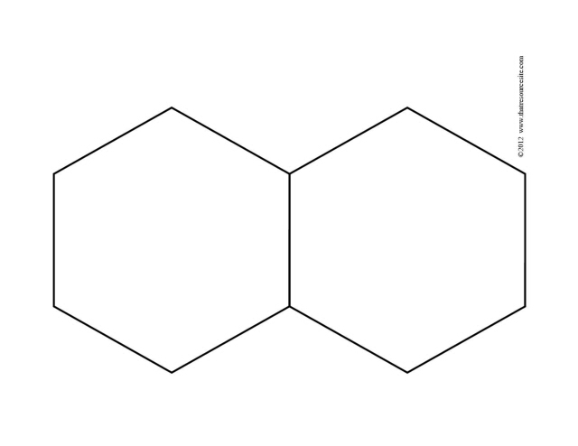
Mammal
vertebrate

