14. Keeping your home language (L1)

It cannot be stressed enough how important it is to keep your home language going and developing. It helps you still communicate with your family and friends in your home country and it helps your brain get stronger. There is loads of research showing how truly bilingual people have better brains and are able to deal with complex problems and brainwork as your brain is exercised all the time by using 2 (or more) languages. So what can you do?

- Agree with your family just to speak L1 at home and nothing else. If that is not possible choose half an hour or an hour everyday when you can do this.
- Look at books and films in L1. The library can help you get books, or you could ask a relative in your home country to send some over. You can also get books online to read. Try books you like translated - like Harry Potter/
- Read to your younger brother or sister in L1, this gives you practice and teaches them too.
- Switch your computer to L1 so all the instructions are in your home language. You can also do this with the X-Box or the Playstation.
- Plan some of your work in L1 so that you are developing academic language in your home language too.
- Look at Duolingo https://www.duolingo.com/ or other resource to help you learn more in L1. (You could even see if there is a Nat5/Higher in your home language too).
- Use a Bilingual dictionary … you can get picture dictionaries too Picture dictionary
- Have a look at this leaflet if you don’t believe me! http://www.ealhighland.org.uk/wp-content/uploads/English-Be-Bilingual-A4-Trifold-v5.pdf

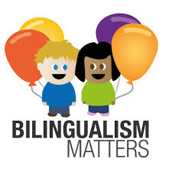
There are places that support bilingual families and learning too. Bilingualism Matters: About us

