- MIND MAPS

Mindmaps are a great way of collecting information about any subject or collecting your thoughts and helping you to remember things that are connected. You can have simple mindmaps like this….

Or more complex ones like this….
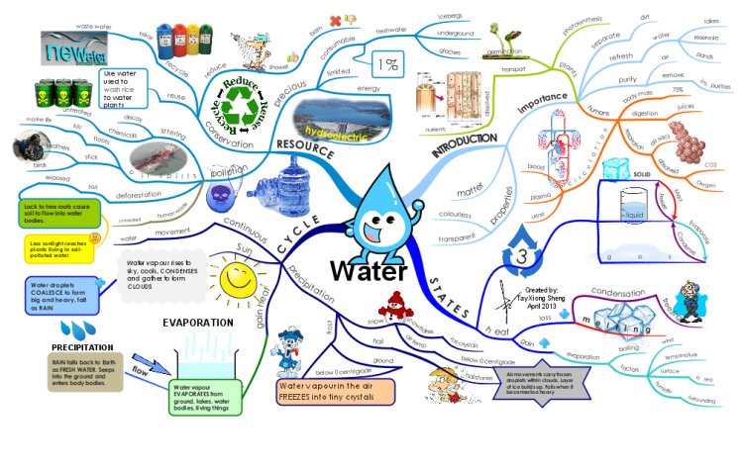
Use them for remembering anything from:
- The meanings of words (put the word in the middle and write any word that connects with it round the edge)
- to planning an essay for any subject (put the essay title in the middle and plan out the different paragraphs or points you want to make round the edge, then number them for the right order you want to write them in)
- to revising for a topic (put the topic in the middle and then everything you need to remember round the edge for example Romans then round the edge stories about Romans, Gods and Goddesses, places the Romans went, places the Romans built, Roman food, Roman language etc)
– just be creative.
You can also find them online…
https://www.matchware.com/mind-mapping-free
and for Chromebook
https://chrome.google.com/webstore/detail/mindmup-20-free-mind-map/mkgkheknpfngchmoaognoilfanomldfl?hl=en

